Question 1 [10 points]
Write the results of the following queries for the data in the tables (in the data shared)
- SELECT id FROM Books WHERE Quantity > 5;

- SELECT m.Name, COUNT(l.Id) AS Loan_Count
FROM Members m, Loans l
WHERE m.Id = l.Member_Id
GROUP BY m.Name HAVING COUNT(*) > 1;

- SELECT b.Title, COUNT(l.lid) AS Total_Loans
FROM Books b, Loans l WHERE b.Id = l.Book_Id
GROUP BY b.Title;

- SELECT b.Title, COUNT(l.lid) AS Total_Loans
FROM Books b left outer join Loans l on b.Id = l.Book_Id
GROUP BY b.Title;

- SELECT m.Name, COUNT(*) AS Total_Loans
FROM Members m, Loans l WHERE m.Id = l.Member_Id
GROUP BY m.Name
ORDER BY Total_Loans DESC
LIMIT 2;

- SELECT b.Title FROM Books b,Loans l
WHERE l.return_date IS NULL and b.Id = l.Book_Id ;

- Select b.title, b.Quantity - loaned from books b,
( SELECT b.id, count(*) as loaned FROM Books b,Loans l
WHERE l.return_date IS NULL and b.Id = l.Book_Id ) loaned_books lb
Where b.id=lb.id;

- SELECT MONTH(Loan_Date) AS Month, COUNT(*)
FROM Loans
GROUP BY MONTH(Loan_Date);

Books
Id | Title | Author | Genre | Quantity
1 | Pride and Prejudice | Jane Austen | Fiction | 5
2 | A Brief History of Time | Stephen Hawking | Science | 3
3 | The Catcher in the Rye | J.D. Salinger | Fiction | 4
4 | The Great Gatsby | F. Scott Fitzgerald | Fiction | 2
5 | Sapiens: A Brief History of Humankind | Yuval Noah Harari | Non-Fiction | 3
6 | Educated | Tara Westover | Non-Fiction | 2
7 | The Silent Patient | Alex Michaelides | Thriller | 5
8 | The Alchemist | Paulo Coelho | Fiction | 7
Members
Id | Name | Email | Phone
1 | Sarah Thompson | sarah@example.com | 555-1234
2 | Michael Johnson | michael@example.com | 555-5678
3 | Emma Brown | emma@example.com | 555-9012
4 | James Wilson | james@example.com | 555-3456
5 | Olivia Smith | olivia@example.com | 555-7890
6 | Alex Saxton | saxtona@example.com | 555-7210
Loans
Id | Loan_Date | Member_Id | Book_Id | Return_Date
1 | 1/15/2023 | 1 | 1 | 1/22/2023
2 | 2/10/2023 | 1 | 2 | 2/17/2023
3 | 3/5/2023 | 2 | 3 | NULL
4 | 3/12/2023 | 3 | 4 | 3/19/2023
5 | 4/1/2023 | 1 | 4 | NULL
6 | 4/15/2023 | 4 | 4 | 4/22/2023
7 | 5/1/2023 | 2 | 7 | 5/8/2023
8 | 5/15/2023 | 5 | 8 | NULL

Question 2 [10 points]
Convert the following diagram to relational model.

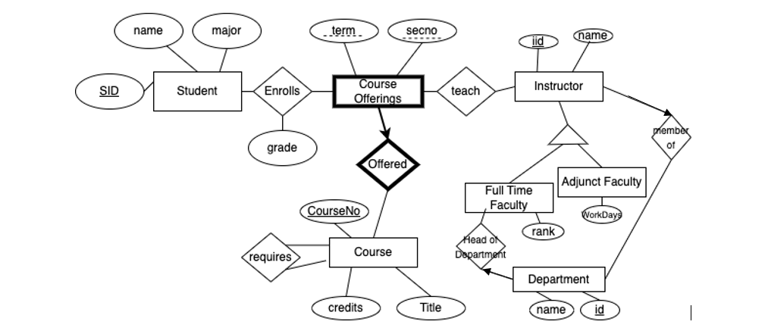

Question 3
A manufacturing company operates multiple assembly plants, each located in different cities. Each assembly plant produces various products. Every part is identified by a unique SKU and has a name; it can either be assembled from other part or can be purchased directly from external suppliers. It is important to note that not all parts are classified as products.
For assembled parts, the company tracks the parts used in the assembly, including the quantity of each part required. Each supplier is identified by a unique ID, has a name, and an address. The company maintains records of the parts that can be supplied by each supplier, including the price for each part.
Furthermore, the company keeps a history of purchases from suppliers, documenting the purchase date and the quantity purchased.
The quantity of each part currently in stock is maintained.
Create an Entity-Relationship Diagram (ERD)

Question 4 [10 points]
Consider the following schema (keys are underlined):
- Students (StudentID, FirstName, LastName, Major)
- Courses (CourseID, CourseName, Credits)
- CourseOfferings (OfferingID, CourseID, Semester, Instructor)
- Prerequisites (CourseID, PrerequisiteID)
- Enrollments (StudentID, OfferingID, Grade)
  - Assume grade is presented as a numeric value. For example, A is 4 and C is 2
Given T1 as SELECT * from COURSE C, Enrollment E, CourseOfferings CO, Sudents S
Where ....

1. List Students in a specific class
Retrieve the first and last names of all students that has enrolled in Database Course in Fall 2024
2. Retrieve Courses Taken by a Specific Student
Find all course names that a student with StudentID = 12345 has enrolled in.
3. Check Prerequisite Courses for a Course
List all the prerequisite courses for a specific course, CourseID = 'CS4550'.
4. List All Students and Their Enrolled Courses
Retrieve a list of all students along with the courses they are enrolled in. For each course, include the instructor's name.
5. Find Students Enrolled in a Course Without Completing Prerequisites
Identify students who are currently enrolled in a course but have not completed the prerequisite courses. Assume that a course is considered completed if the student has earned a grade higher than 1.5
Get the perquisite for a course
Select PrerequisiteID from Prerequisites where cid in

Find Students Enrolled in a Course while Completing all Prerequisites
With Course_taken as (select distinct studentid as Sid, courseid as cid from T1)
SELECT * FROM course c, student S , Course_taken ct
Where c.studentid=ct.sid and ct.cid=c.courseid and NOT Exists (
SELECT * from Prerequisite p where course_id =c.courseid
Where not EXISTs ( SELECT * FROM ct
Where p.course_id=ct.cid)
6. Find the Most Popular Course (Based on Enrollment Count) in a Specific Semester
Determine the course with the highest number of enrollments in the semester 'Fall 2023'.
7. Find Students with Highest Grade in a Specific Course Offering
Find the student who received the highest grade in a specific course offering, say OfferingID = 2001.
8. List All Courses a Student Needs to Take to Meet Prerequisites
Given a StudentID, list all the courses that the student has not yet taken but are prerequisites for courses they are currently enrolled in.
9. Find Courses with No Enrollments in a given Semester
Retrieve a list of course offering that were offered in Fall 2023 but had no students enrolled.

